|  |
| --- |
| **SAVEETHA INSTITUTE OF MEDICAL AND TECHNICAL SCIENCES** |
| **COMPUTER SCIENCE AND ENGINEERING PROGRAMME** |

**CSA4053 – MANAGMENT INFORMATION SYSTEM**

**LAB SESSION**

1. **Develop a simple login page using service -base database in visual studio.**

**Code:** Imports System.Data.SqlClient

Imports System.Windows

Public Class Form1

Dim conn As New SqlConnection

Dim cmd As New SqlCommand

Dim dt As DataTable

Dim dr As SqlDataReader

Dim da As New SqlDataAdapter

Dim str As String

Private Sub Form1_Load(sender As Object, e As EventArgs) Handles MyBase.Load

conn.ConnectionString = "Data Source=(LocalDB)\MSSQLLocalDB;AttachDbFilename=C:\Users\pulla\source\repos\demo1\demo1\Database1.mdf;Integrated Security=True"

End Sub

Private Sub Button1_Click(sender As Object, e As EventArgs) Handles Button1.Click

conn.Open()

str = "Select * from login where username='" & TextBox1.Text & "' and password ='" & TextBox2.Text & "'"

cmd = New SqlCommand(str, conn)

da = New SqlDataAdapter(cmd)

dt = New DataTable

da.Fill(dt)

If (dt.Rows.Count > 0) Then

MsgBox("Entry accessed")

Me.Show()

Else

MsgBox("Invalid username & password")

End If

cmd.ExecuteNonQuery()

cmd.Dispose()

conn.Close()

End Sub

End Class

**Proof :**

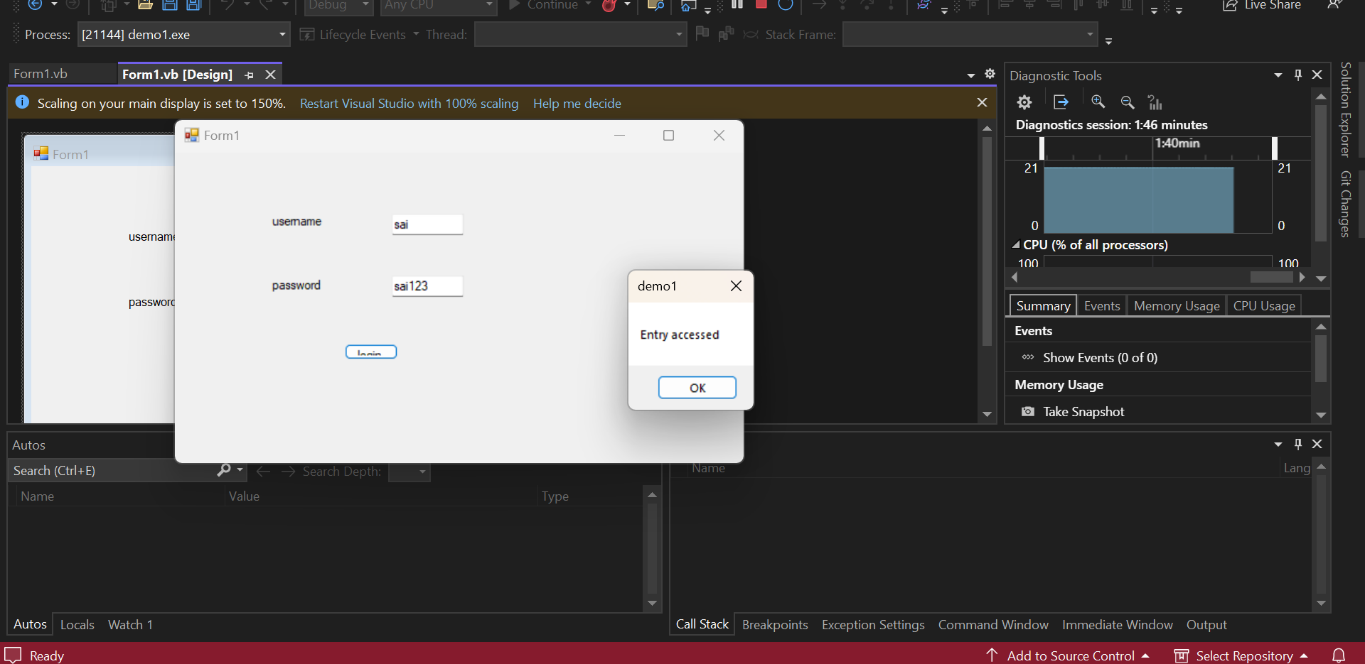

1. Develop the student details using service based database in visual studio

**Code:**

Imports System.Data.SqlClient

Public Class Form1

Dim conn As New SqlConnection

Dim cmd As New SqlCommand

Dim dt As DataTable

Dim dr As SqlDataReader

Dim da As New SqlDataAdapter

Dim str As String

Private Sub Label8_Click(sender As Object, e As EventArgs) Handles Label8.Click

End Sub

Private Sub Form1_Load(sender As Object, e As EventArgs) Handles MyBase.Load

'TODO: This line of code loads data into the 'DetailsDataSet1.details' table. You can move, or remove it, as needed.

Me.DetailsTableAdapter.Fill(Me.DetailsDataSet1.details)

conn.ConnectionString = "Data Source=(LocalDB)\MSSQLLocalDB;AttachDbFilename=D:\folders\MIS\Program_1\Program_1\details.mdf;Integrated Security=True"

End Sub

Private Overloads Sub Insert(sender As Object, e As EventArgs) Handles Button1.Click

conn.Open()

str = "insert into details values('" & TextBox1.Text & "','" & TextBox2.Text & "','" & TextBox3.Text & "', '" & DateTimePicker1.Value.Date & "', '" & RichTextBox1.Text & "' , '" & TextBox4.Text & "','" & TextBox5.Text & "','" & TextBox6.Text & "' , '" & RichTextBox2.Text & "' )"

cmd = New SqlCommand(str, conn)

If cmd.ExecuteNonQuery() Then

MsgBox("successfully inserted")

End If

cmd.Dispose()

conn.Close()

End Sub

Private Overloads Sub Update(sender As Object, e As EventArgs) Handles Button2.Click

conn.Open()

str = "update details set Name='" & TextBox1.Text & "', Regno=" & TextBox2.Text & " where Regno =" & TextBox2.Text & ""

cmd = New SqlCommand(str, conn)

If cmd.ExecuteNonQuery() Then

MsgBox("successfully updated")

End If

cmd.Dispose()

conn.Close()

End Sub

Private Overloads Sub Delete(sender As Object, e As EventArgs) Handles Button3.Click

conn.Open()

str = "Delete from details where Regno ='" & TextBox2.Text & "'"

cmd = New SqlCommand(str, conn)

If cmd.ExecuteNonQuery() Then

MsgBox("successfully deleted")

End If

cmd.Dispose()

conn.Close()

End Sub

Private Overloads Sub View(sender As Object, e As EventArgs) Handles Button4.Click

DataGridView1.Visible = True

conn.Open()

str = "select * from details"

cmd = New SqlCommand(str, conn)

da = New SqlDataAdapter(cmd)

dt = New DataTable

da.Fill(dt)

DataGridView1.DataSource = dt

cmd.Dispose()

conn.Close()

End Sub

End Class

**Proof :**

